ACTIVITY REPORT
Attendance:
___8____ members
___42____ non-members
___7____ staff
___0____ invited guests
Organiser : UTAR Yoga Society & Isha Foundation__________________________________________
Activity Name : “Yoga for Beginners” Returns: A Peaceful Evening
with Isha Foundation__________________________________________
Date : 18 July 2025 (Friday)__________________________________________
Time : 6:30 pm – 7:30 pm__________________________________________
Venue : Performing Arts Studio (KB111 & KB112), Sungai Long Campus.

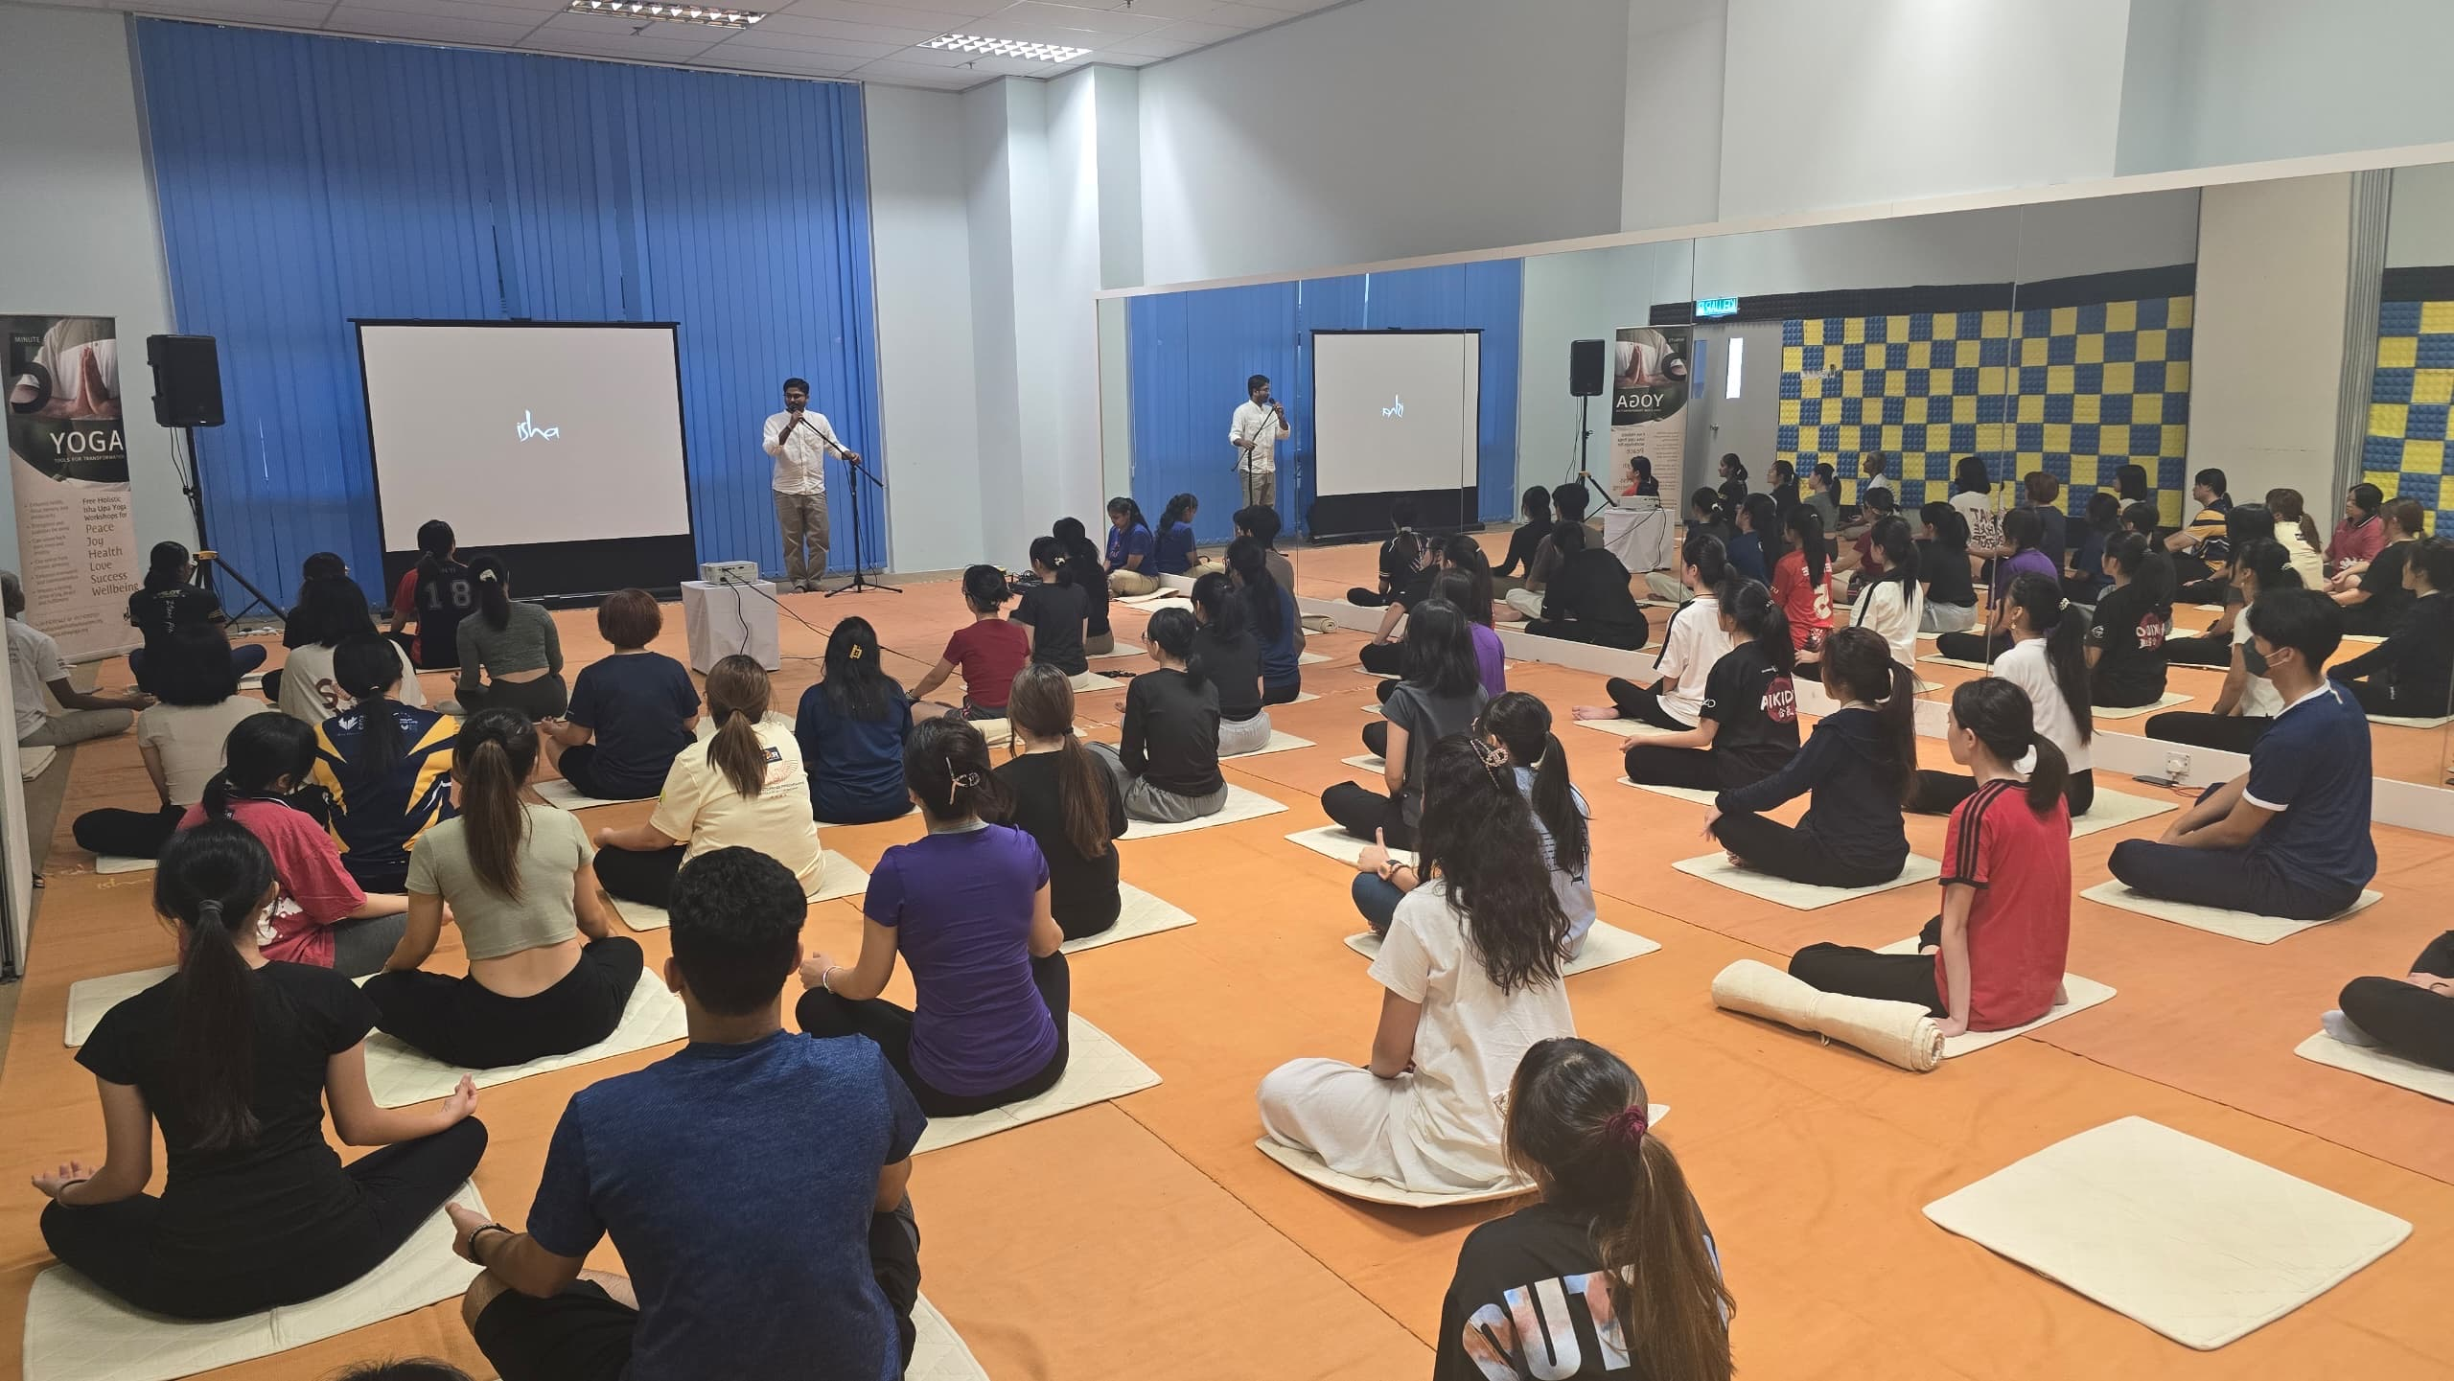
Participants enjoying the yoga session in KB111 & KB112, Sungai Long Campus

Following the success of its previous session, UTAR Sungai Long Yoga Society once again collaborated with Isha Foundation Malaysia to host a second “Yoga for Beginners” event on 18 July 2025 (Friday) from 6:00 PM to 7:30 PM at the Performing Arts Studio (KB111 & KB112), Sungai Long Campus.

This free session welcomed 49 participants from diverse backgrounds, including UTAR students, academic and administrative staff, and members of the public. The aim was to promote wellness through classical yoga practices guided by trained volunteers from Isha Foundation Malaysia. Despite busy schedules, the event drew a full house, with attendees eager to unwind and reconnect with themselves through gentle movement and mindful breathing.
A Guided Journey into Inner Stillness
The session featured a well-structured series of beginner-friendly yoga postures, breathing techniques, and a guided meditation session using the “Miracle of Mind” App by Sadhguru. The yoga guide shared the ancient wisdom behind each practice, focusing on improving posture, breathing awareness, and inner balance. Participants were encouraged to practice attentively, fostering not just physical benefits but also emotional and mental clarity.
The Performing Arts Studio provided a quiet and, comfortable atmosphere that enhanced the experience, allowing participants to focus inward in a serene setting. Volunteers from the Yoga Society, Isha Foundation Malaysia and supporting academic staff (indicated below) played a key role in setting up, managing the session, and supporting newcomers throughout the event.
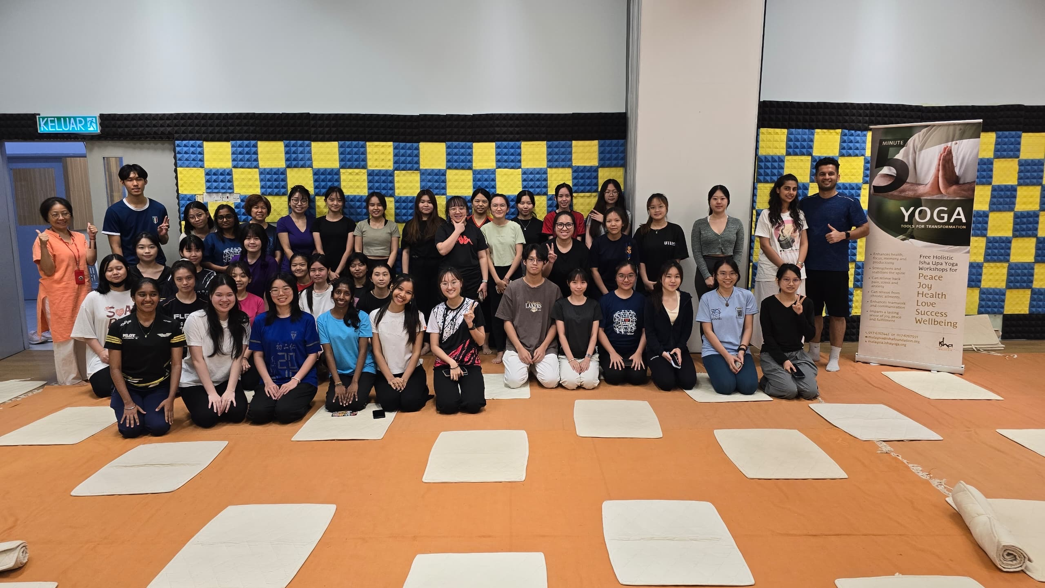
Volunteers and participants smiling after the session

Participant’s Feedback
The positive response to the session were overwhelming, with many participants expressing their appreciation:
“Isha yoga event gave me an unforgettable experience and I also learned a lot about yoga. I felt enjoyment, peace and relaxation in this Isha yoga activity.”
“It was my first-time trying yoga, and I felt surprisingly calm and energised afterward. The instructors were very clear and patient.”
“I used to think yoga was just stretching, but now I know it’s so much more. I left the room feeling centered and stress-free.”
“This session helped me discover how out of sync my breathing was. After applying the techniques, I feel much more in control of my emotions, Thank you UTAR and Isha Foundation!”
“Loved the group energy and the flow of the class. It was healing both mentally and physically.”

Moving Forward
This event was made possible by the collaborative efforts of UTAR Yoga Society members, including Lavanya Kannagaraju, Vivian Tang Yen Ai, Choong An Qi, Pong En Ni, Lam Mun E, Geogina Adrianna Stalin Jerah, Tarveen Kaur Jura Singh, Chong Ming Hui, Chong Ming Yue, Seah Jun Wei, and Gan Yi Zhe along with support from academic staff Dr Yong Mun Ching, Mr. Fernando Andrade, and Dr Jayamalathi Jayabalan, as well as the dedicated volunteers from Isha Foundation Malaysia.
UTAR Yoga Society hopes to continue hosting events that support student wellness and encourage holistic development through physical, emotional, and spiritual wellbeing. With growing interest and positive feedback, future collaborations with Isha Foundation are highly anticipated.

Reported by:

___________________________ _________________________ ______________________
Vivian Tang Yen Ai
Auditor, Yoga Society Designation Date: 02 August 2025

